DIVERSITY EQUITY INCLUSION POLICY
RATIONALE
“We believe that exemplifying and embracing diversity, equity, and inclusion (DEI) should be a part of everything we do at Rotary.
At Rotary, we understand that cultivating a diverse, equitable, and inclusive culture is essential to realizing our vision of a world where people unite and take action to create lasting change.
We value diversity and celebrate the contributions of people of all backgrounds, across age, ethnicity, race, colour, disability, learning style, religion, faith, socioeconomic status, culture, marital status, languages spoken, sex, sexual orientation, and gender identity as well as differences in ideas, thoughts, values, and beliefs.
Recognizing that individuals from certain groups have historically experienced barriers to membership, participation, and leadership, we commit to advancing equity in all aspects of Rotary, including in our community partnerships, so that each person has the necessary access to resources, opportunities, networks, and support to thrive.
We believe that all people hold visible and invisible qualities that inherently make them unique, and we strive to create an inclusive culture where each person knows they are valued and belong.
In line with our value of integrity, we are committed to being honest and transparent about where we are in our DEI journey as an organization, and to continuing to learn and do better.” (Rotary International DEI Taskforce 2022)

DEFINITIONS
DIVERSITY: People of all backgrounds, experiences, and identities regardless of their age, ethnicity, race, colour, abilities, religion, socioeconomic status, culture, sex, sexual orientation, or gender identity.
EQUITY: Carefully considering how to provide differing levels of support, opportunities, and resources so participants have a welcoming and productive experience.
INCLUSION: Creating experiences in which all people are welcomed, respected, and valued.
“Diversity is being invited to the party, inclusion is being asked to dance.”

CLUB DIVERSITY, EQUITY AND INCLUSION GOAL
  - Building a diverse, equitable and inclusive club culture
Building a diverse, equitable and inclusive club provides psychological safety for our diverse group of club members to be accepted into Rotary as they are, without limitation or prejudice.
At our club we endeavour to celebrate the uniqueness of each individual. Each club member knows that their feedback is valued and encouraged and from that, dialogue can take place to investigate the implementation of change that will build a more inclusive culture. DEI work is an area upon which we can always improve.
KEY PERFORMANCE INDICATORS (KPI’s)
“What gets measured, gets done.”
- WELCOME
KPI 1.1: To be a welcoming and supportive club to all members and those enquiring about membership. (Measured by the warmth and genuine interest in club members and their families by other members).

- REPRESENTATION
- KPI 2.1: To improve representation of underrepresented community groups at all levels of the club. To not make this a token representation of a minority group but rather, encourage a broader cohort. (Measured by the diverse range of community groups represented in club membership).
- KPI 2.2: To be aware of the diversity of abilities within the community, and recognise that as a club we could grow by embracing the skills they would bring. (Measured by the Membership Team, with the support of club members, inviting people of diverse abilities to attend a club information session).

- ENGAGEMENT
- KPI 3.1: To provide access to activities and organisational roles that result in meaningful engagement in club events regardless of ability. (Measured by participation of club members in organising and engaging in events eg “Holding Hands, Holding Hearts”).

- KPI 3.2: To make our club accessible and inclusive of all abilities and backgrounds. (Measured by accessibility of venues, time and place of events, financial support for fees/meals/activities and associated costs available, the ability to pay membership fees in instalments).

- KPI 3.3: For club leaders to understand why each member is in Rotary and determine what activities would fulfill their passion and purpose for joining. The delegation of tasks and roles to be inclusive of club members’ desires where possible, with the provision of a mentor when required. (Measured by participation of members in club activities with support/mentoring provided where necessary).

- KPI 3.4: For club members to assume responsibility for DEI within the club as it is the responsibility of every member. Each club member can impact upon the DEI practices of the club. (Measured by the support of the club in implementing the DEI policy and associated practices).

    - PROFESSIONAL DEVELOPMENT
- KPI 4.1: To provide all club members with opportunities to broaden their knowledge of DEI principles through the engagement of speakers on relevant topics. (Measured by engagement of DEI focussed speakers invited to share their story with the club).

- KPI 4.2 To increase club members knowledge and understanding of diversity in the community by celebrating significant days or weeks such as Harmony Day, NAIDOC week, International Women’s Day, Pride Week etc. through targeted and incidental education. (Measured by club engagement in themed events, club ribbon promotion, bulletin promotion, attendance at special events).

- KPI 4.3 To increase club member’s knowledge and understanding of DEI principles through encouraging the undertaking of Rotary Learning Centre training. Club members are encouraged to complete courses provided by the Rotary Learning Centre and seek assistance to do so when required. (Measured by completion certificates being issued and celebrated).

- RETENTION
KPI 5.1: To conduct regular surveys of club members to ascertain areas for improvement as a club and celebrate areas considered by club members to be successful. (Measured by the implementation of surveys and consideration of the results that are shared with the club.)
KPI 5.2 To conduct formal or informal exit surveys and identify any trends requiring attention in the area of DEI. (Measured by the implementation of surveys and consideration of the results)
- LEADERSHIP
KPI 6.1 To provide opportunities for the inclusion of diversity in leadership roles within the club. This will be supported by the provision of a mentor to develop the skills and competencies required of the task. It is acknowledged that Director’s Roles within the club require a specific set of key competencies but the opportunity to support club members in roles that are not onerous on the mentor or beyond the competencies of the member seeking a leadership role, will be encouraged. (Measured by club members being given the opportunity to be supported in roles that reflect the skills of the members seeking leadership opportunities).
KPI 6.2 To provide mentors for those seeking opportunities to lead the club in activities or events. All club members will be given the opportunity to lead or assist with leading the club in range of projects and will be supported by a mentor to ensure the success of the leadership. The mentor will be an experienced club member with the necessary competencies to support the club member through the task. (Measured by success of completion of role)
- PROMOTE AND INCREASE AWARENESS OF DEI PRINCIPLES AT CLUB LEVEL.
KPI 7.1 To talk about DEI formally and informally and keep club members informed of our club’s efforts. (Measured by the level of sharing at meetings or social gatherings).
KPI 7.2 To promote our club’s DEI activities through social media, the bulletin, website etc. (Measured by the inclusion of DEI activities posted and shared on social media)

KPI 7.3 To keep club members informed of progress on meeting KPI’s. (Measured by the inclusion of DEI KPI feedback at club level).

RESOURCES

The provision of support to ensure the inclusion of DEI principles in the club can occur in the following ways:
- Holding Hands holding Hearts (Club members)
- Surveys (Board members)
- Social Media, website (PI Team)
- Bulletin (Geoff)
- Leadership Training (Rotary Learning Centre)
- Mentors (Club members with competencies required)

BUDGET

The Rotary Club of East Maitland will support the implementation of DEI principles in the club through the provision of financial support, as approved by the Board of Directors.

Targeted events held for specific projects such as Holding Hands Holding Hearts may require financial support for materials and resources, participation in activities, meals equipment hire etc. A request for financial support will be made formally to the Board prior to an event.

EVALUATION

This policy will be reviewed annually.

1.REFERENCES
1. Some examples of key or core competencies in leadership are in the diagram below. The role of Treasurer would have additional specific financial management competencies.
B

Customize your content your way
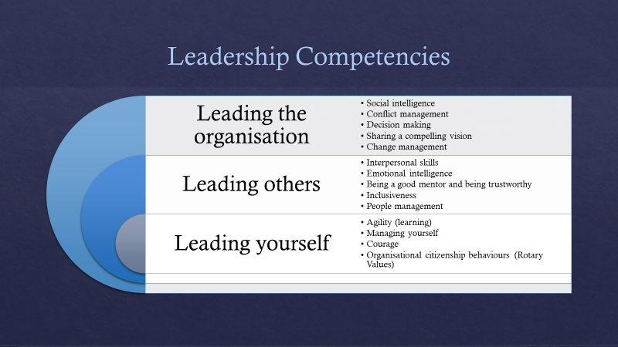

2. ROTARY CLUB OF EAST MAITLAND

APPLICATION FOR FINANCIAL SUPPORT FOR DEI EVENT TO BE SUBMITTED TO THE BOARD FOR APPROVAL
NAME OF EVENT | PROPOSED DATE | DESCRIPTION | ESTIMATED BUDGET REQUIRED
Name of Club member organising the event | Date of application | Number of volunteers required

KEY PERFORMANCE INDICATORS
KPI | CRITERIA FOR SUCCESS | ACHIEVED | COMMENTS
KPI 1.1  Welcome | Warmth and genuine interest in club members
KPI 2.1  REPRESENTATION | Diversity amongst membership
KPI 2.2  REPRESENTATION | Diversity in prospective membership
KPI 3.1  ENGAGEMENT | Meaningful engagement supported by club members
KPI 3.2  ENGAGEMENT | Accessible and inclusive of all abilities
KPI 3.3  ENGAGEMENT | Full participation by members with support where necessary
KPI 3.4  ENGAGEMENT | Club engaging in DEI practices
KPI 4.1  PROFESSIONAL DEVELOPMENT | Engaging DEI speakers
KPI 4.2  PROFESSIONAL DEVELOPMENT | Increase members understanding of DEI through ribbon promotion, bulletin, themed events.
KPI 4.3  PROFESSIONAL DEVELOPMENT | Engagement of members in Rotary Learning Centre DEI topics
KPI 5.1  RETENTION | Implementation of club satisfaction surveys
KPI 5.2  RETENTION | Consideration of exit survey results
KPI 6.1  LEADERSHIP | Structured and supported leadership opportunities given to members (within their competency range).
KPI 6.2  LEADERSHIP | Success of leadership role
KPI 7.1  PROMOTE AND INCREASE AWARENESS | Sharing at meeting, gatherings
KPI 7.2  PROMOTE AND INCREASE AWARENESS | DEI activities promoted by club
KPI 7.3  PROMOTE AND INCREASE AWARENESS | Feedback to clUb members

1

